**6. Kubernetes NodePort Service Introduction**

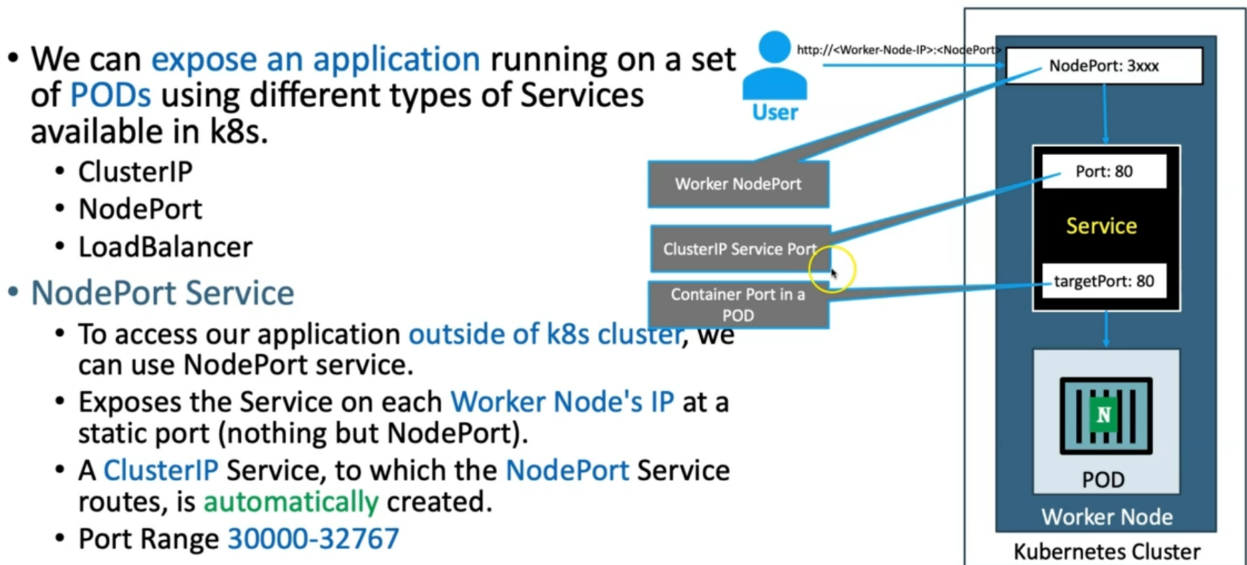

--- **note** – you have a kubernetes cluster with worker node here and also, we have created a nodeport service, every service will have its own port and this port is nothing but a cluster ip service port. In service you will also have target port which is nothing but a container port.

--- worker nodeport will start from 30000-32767. When you define nodeport using imperative way then you have no control over nodeport, the nodeport will generate automatically by kubernetes.

--- when use declarative way to define nodeport then you can define a particular nodeport.

**Application traffic flow**

--- http://<worker-Node-IP>:<NodePort> - want to access the application over internet.

--- **note** – the traffic comes via nodeport and from there traffic will be sent to the clusterIP service port, from there it will be sent to the target port which is nothing but container port.